**Name**:Dhairya Patil **Class:** TY-15 (Batch C) **Roll Number:** 2223929

**Enrolment Number:** MITU22BTCS0256

**Experiment No. 7**

**Experiment No. 7**

## Introduction

**Study of Classification learning block using a NN Classifier on Edge Devices**

**Objective:** Build a project to detect the keywords using built-in sensor on Nano BLE Sense / Mobile Phone

**Tasks:**

* Generate the dataset for keyword
* Configure BLE Sense / Mobile for Edge Impulse
* Building and Training a Model

## Study of Confusion matrix

## Introduction

Edge Impulse is a development platform for machine learning on edge devices, targeted at developers who want to create intelligent device solutions. The "classification block" equivalent in Edge Impulse would typically involve creating a simple machine learning model that can run on an edge device, like classifying sensor data or recognizing a basic pattern.

## Materials Required

* Nano BLE Sense Board

## Theory

GPIO (General Purpose Input/Output) pins on the Raspberry Pi are used for interfacing with other electronic components. BCM numbering refers to the pin numbers in the Broadcom SOC channel, which is a more consistent way to refer to the GPIO pins across different versions of the

Here’s a high-level overview of steps you'd follow to create a "Hello World" project on Edge Impulse:

**Steps to Configure the Edge Impulse:**

1. Create an Account and New Project:

* Sign up for an Edge Impulse account.
* Create a new project from the dashboard.

1. Connect a Device:

* You can use a supported development board or your smartphone as a sensor device.
* Follow the instructions to connect your device to your Edge Impulse project.

1. Collect Data:

* Use the Edge Impulse mobile app or the Web interface to collect data from the onboard sensors.
* For a "Hello World" project, you could collect accelerometer data, for instance.

1. Create an Impulse:

* Go to the 'Create impulse' page.
* Add a processing block (e.g., time-series data) and a learning block (e.g., classification).
* Save the impulse, which defines the machine learning pipeline.

1. Design a Neural Network:

* Navigate to the 'NN Classifier' under the 'Learning blocks'.
* Design a simple neural network. Edge Impulse provides a default architecture that works well for most basic tasks.

1. Train the Model:

* Click on the 'Start training' button to train your machine learning model with the collected data.

1. Test the Model:

* Once the model is trained, you can test its performance with new data in the 'Model Testing' tab.

1. Deploy the Model:

* Go to the 'Deployment' tab.
* Select the deployment method that suits your edge device (e.g., Arduino library, WebAssembly, container, etc.).
* Follow the instructions to deploy the model to your device.

1. Run Inference:

* With the model deployed, run inference on the edge device to see it classifying data in real-time.

1. Monitor:

You can monitor the performance of your device through the Edge Impulse studio

1. Dataset Image

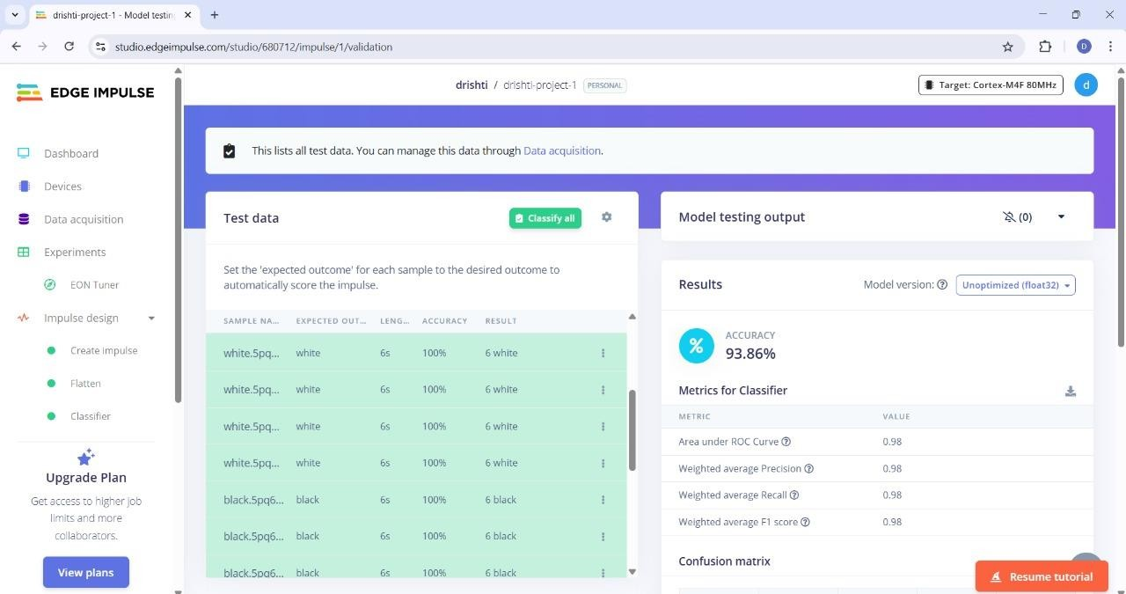

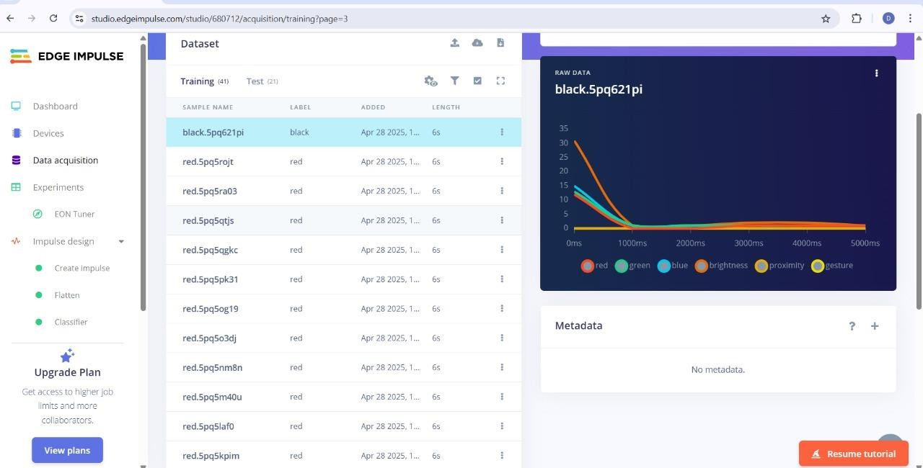

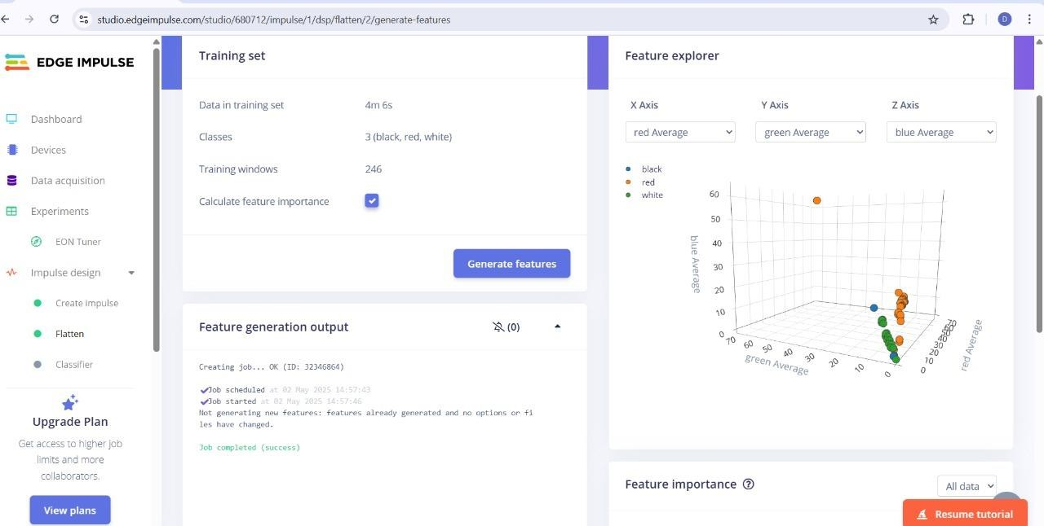

1. **Copy of the Arduino Code**

*/* Edge Impulse ingestion SDK*

* *Copyright (c) 2022 EdgeImpulse Inc.*

*\**

* *Licensed under the Apache License, Version 2.0 (the "License");*
* *you may not use this file except in compliance with the License.*
* *You may obtain a copy of the License at*
* [*http://www.apache.org/licenses/LICENSE-2.0*](http://www.apache.org/licenses/LICENSE-2.0)
* *Unless required by applicable law or agreed to in writing, software*
* *distributed under the License is distributed on an "AS IS" BASIS,*
* *WITHOUT WARRANTIES OR CONDITIONS OF ANY KIND, either express or implied.*
* *See the License for the specific language governing permissions and*
* *limitations under the License.*

*\*/*

*/* Includes*

*\*/*

#include <Color-Detection_inferencing.h>

#include <Arduino_LSM9DS1.h> *//Click here to get the library:* [*https://www.arduino.cc/reference/en/libraries/arduino_lsm9ds1/*](http://www.arduino.cc/reference/en/libraries/arduino_lsm9ds1/)#include <Arduino_LPS22HB.h> *//Click here to get the library:* [*https://www.arduino.cc/reference/en/libraries/arduino_lps22hb/*](http://www.arduino.cc/reference/en/libraries/arduino_lps22hb/)#include <Arduino_HTS221.h> *//Click here to get the library:* [*https://www.arduino.cc/reference/en/libraries/arduino_hts221/*](http://www.arduino.cc/reference/en/libraries/arduino_hts221/)#include <Arduino_APDS9960.h> *//Click here to get the library:* [*https://www.arduino.cc/reference/en/libraries/arduino_apds9960/*](http://www.arduino.cc/reference/en/libraries/arduino_apds9960/)

enum sensor_status { NOT_USED = -1, NOT_INIT,

INIT, SAMPLED

};

*/** Struct to link sensor axis name to sensor value function */*

typedef struct{ const char *name; float *value;

uint8_t (*poll_sensor)(void); bool (*init_sensor)(void); sensor_status status;

} eiSensors;

*/* Constant defines*

*\*/*

#define CONVERT_G_TO_MS2 9.80665f

*/\*\**

* *When data is collected by the Edge Impulse Arduino Nano 33 BLE Sense*
* *firmware, it is limited to a 2G range. If the model was created with a*
* *different sample range, modify this constant to match the input values.*
* *See https://github.com/edgeimpulse/firmware-arduino-nano-33-ble- sense/blob/master/src/sensors/ei_lsm9ds1.cpp*
* *for more information.*

*\*/*

#define MAX_ACCEPTED_RANGE 2.0f

*/** Number sensor axes used */*

#define N_SENSORS 18

*/* Forward declarations*

*- */*

float ei_get_sign(float number);

bool init_IMU(void); bool init_HTS(void); bool init_BARO(void); bool init_APDS(void);

uint8_t poll_acc(void); uint8_t poll_gyr(void); uint8_t poll_mag(void); uint8_t poll_HTS(void); uint8_t poll_BARO(void); uint8_t poll_APDS_color(void);

uint8_t poll_APDS_proximity(void); uint8_t poll_APDS_gesture(void);

*/* Private variables*

*\*/*

static const bool debug_nn = false; *// Set this to true to see e.g. features generated from the raw signal*

static float data[N_SENSORS];

static bool ei_connect_fusion_list(const char *input_list);

static int8_t fusion_sensors[N_SENSORS]; static int fusion_ix = 0;

*/** Used sensors value function connected to label name */*

eiSensors sensors[] =

{

"accX", &data[0], &poll_acc, &init_IMU, NOT_USED,

"accY", &data[1], &poll_acc, &init_IMU, NOT_USED, "accZ", &data[2], &poll_acc, &init_IMU, NOT_USED, "gyrX", &data[3], &poll_gyr, &init_IMU, NOT_USED, "gyrY", &data[4], &poll_gyr, &init_IMU, NOT_USED, "gyrZ", &data[5], &poll_gyr, &init_IMU, NOT_USED, "magX", &data[6], &poll_mag, &init_IMU, NOT_USED, "magY", &data[7], &poll_mag, &init_IMU, NOT_USED, "magZ", &data[8], &poll_mag, &init_IMU, NOT_USED,

"temperature", &data[9], &poll_HTS, &init_HTS, NOT_USED, "humidity", &data[10], &poll_HTS, &init_HTS, NOT_USED,

"pressure", &data[11], &poll_BARO, &init_BARO, NOT_USED,

"red", &data[12], &poll_APDS_color, &init_APDS, NOT_USED, "green", &data[13], &poll_APDS_color, &init_APDS, NOT_USED, "blue", &data[14], &poll_APDS_color, &init_APDS, NOT_USED, "brightness", &data[15], &poll_APDS_color, &init_APDS, NOT_USED,

"proximity", &data[16], &poll_APDS_proximity, &init_APDS, NOT_USED, "gesture", &data[17], &poll_APDS_gesture,&init_APDS, NOT_USED,

};

*/\*\**

*\* @brief Arduino setup function*

*\*/*

void setup()

{

*/* Init serial */*

Serial.begin(115200);

*// comment out the below line to cancel the wait for USB connection (needed for native USB)*

while (!Serial);

Serial.println("Edge Impulse Sensor Fusion Inference\r\n");

*/* Connect used sensors */*

if(ei_connect_fusion_list(EI_CLASSIFIER_FUSION_AXES_STRING) == false) { ei_printf("ERR: Errors in sensor list detected\r\n");

return;

}

*/* Init & start sensors */*

for(int i = 0; i < fusion_ix; i++) {

if (sensors[fusion_sensors[i]].status == NOT_INIT) { sensors[fusion_sensors[i]].status =

(sensor_status)sensors[fusion_sensors[i]].init_sensor(); if (!sensors[fusion_sensors[i]].status) {

ei_printf("%s axis sensor initialization failed.\r\n", sensors[fusion_sensors[i]].name);

}

else {

ei_printf("%s axis sensor initialization successful.\r\n", sensors[fusion_sensors[i]].name);

}

}

}

}

*/\*\**

*\* @brief Get data and run inferencing*

*\*/*

void loop()

{

ei_printf("\nStarting inferencing in 2 seconds...\r\n"); delay(2000);

if (EI_CLASSIFIER_RAW_SAMPLES_PER_FRAME != fusion_ix) { ei_printf("ERR: Sensors don't match the sensors required in the

model\r\n"

"Following sensors are required: %s\r\n", EI_CLASSIFIER_FUSION_AXES_STRING);

return;

}

ei_printf("Sampling...\r\n");

*// Allocate a buffer here for the values we'll read from the sensor*

float buffer[EI_CLASSIFIER_DSP_INPUT_FRAME_SIZE] = { 0 };

for (size_t ix = 0; ix < EI_CLASSIFIER_DSP_INPUT_FRAME_SIZE; ix += EI_CLASSIFIER_RAW_SAMPLES_PER_FRAME) {

*// Determine the next tick (and then sleep later)*

int64_t next_tick = (int64_t)micros() + ((int64_t)EI_CLASSIFIER_INTERVAL_MS * 1000);

for(int i = 0; i < fusion_ix; i++) {

if (sensors[fusion_sensors[i]].status == INIT) { sensors[fusion_sensors[i]].poll_sensor(); sensors[fusion_sensors[i]].status = SAMPLED;

}

if (sensors[fusion_sensors[i]].status == SAMPLED) { buffer[ix + i] = *sensors[fusion_sensors[i]].value; sensors[fusion_sensors[i]].status = INIT;

}

}

int64_t wait_time = next_tick - (int64_t)micros(); if(wait_time > 0) {

delayMicroseconds(wait_time);

}

}

*// Turn the raw buffer in a signal which we can the classify*

signal_t signal;

int err = numpy::signal_from_buffer(buffer, EI_CLASSIFIER_DSP_INPUT_FRAME_SIZE, &signal);

if (err != 0) { ei_printf("ERR:(%d)\r\n", err); return;

}

*// Run the classifier*

ei_impulse_result_t result = { 0 };

err = run_classifier(&signal, &result, debug_nn); if (err != EI_IMPULSE_OK) {

ei_printf("ERR:(%d)\r\n", err); return;

}

*// print the predictions*

ei_printf("Predictions (DSP: %d ms., Classification: %d ms., Anomaly: %d ms.):\r\n",

result.timing.dsp, result.timing.classification, result.timing.anomaly);

for (size_t ix = 0; ix < EI_CLASSIFIER_LABEL_COUNT; ix++) { ei_printf("%s: %.5f\r\n", result.classification[ix].label,

result.classification[ix].value);

}

#if EI_CLASSIFIER_HAS_ANOMALY == 1

ei_printf(" anomaly score: %.3f\r\n", result.anomaly); #endif

}

#if !defined(EI_CLASSIFIER_SENSOR) || (EI_CLASSIFIER_SENSOR != EI_CLASSIFIER_SENSOR_FUSION && EI_CLASSIFIER_SENSOR != EI_CLASSIFIER_SENSOR_ACCELEROMETER)

#error "Invalid model for current sensor" #endif

*/\*\**

* *@brief Go through sensor list to find matching axis name*

*\**

* *@param axis_name*
* *@return int8_t index in sensor list, -1 if axis name is not found*

*\*/*

static int8_t ei_find_axis(char *axis_name)

{

int ix;

for(ix = 0; ix < N_SENSORS; ix++) { if(strstr(axis_name, sensors[ix].name)) {

return ix;

}

}

return -1;

}

*/\*\**

* *@brief Check if requested input list is valid sensor fusion, create sensor buffer*
* *@param[in] input_list Axes list to sample (ie. "accX + gyrY + magZ")*
* *@retval false if invalid sensor_list*

*\*/*

static bool ei_connect_fusion_list(const char *input_list)

{

char *buff;

bool is_fusion = false;

*/* Copy const string in heap mem */*

char *input_string = (char *)ei_malloc(strlen(input_list) + 1); if (input_string == NULL) {

return false;

}

memset(input_string, 0, strlen(input_list) + 1); strncpy(input_string, input_list, strlen(input_list));

*/* Clear fusion sensor list */*

memset(fusion_sensors, 0, N_SENSORS);

fusion_ix = 0;

buff = strtok(input_string, "+");

while (buff != NULL) { */* Run through buffer */*

int8_t found_axis = 0;

is_fusion = false;

found_axis = ei_find_axis(buff);

if(found_axis >= 0) { if(fusion_ix < N_SENSORS) {

fusion_sensors[fusion_ix++] = found_axis; sensors[found_axis].status = NOT_INIT;

}

is_fusion = true;

}

buff = strtok(NULL, "+ ");

}

ei_free(input_string);

return is_fusion;

}

*/\*\**

* *@brief Return the sign of the number*
* *@param number*
* *@return int 1 if positive (or 0) -1 if negative*

*\*/*

float ei_get_sign(float number) { return (number >= 0.0) ? 1.0 : -1.0;

}

bool init_IMU(void) {

static bool init_status = false; if (!init_status) {

init_status = IMU.begin();

}

return init_status;

}

bool init_HTS(void) {

static bool init_status = false; if (!init_status) {

init_status = HTS.begin();

}

return init_status;

}

bool init_BARO(void) {

static bool init_status = false; if (!init_status) {

init_status = BARO.begin();

}

return init_status;

}

bool init_APDS(void) {

static bool init_status = false; if (!init_status) {

init_status = APDS.begin();

}

return init_status;

}

uint8_t poll_acc(void) {

if (IMU.accelerationAvailable()) { IMU.readAcceleration(data[0], data[1], data[2]);

for (int i = 0; i < 3; i++) {

if (fabs(data[i]) > MAX_ACCEPTED_RANGE) {

data[i] = ei_get_sign(data[i]) * MAX_ACCEPTED_RANGE;

}

}

data[0] *= CONVERT_G_TO_MS2; data[1] *= CONVERT_G_TO_MS2; data[2] *= CONVERT_G_TO_MS2;

}

return 0;

}

uint8_t poll_gyr(void) {

if (IMU.gyroscopeAvailable()) { IMU.readGyroscope(data[3], data[4], data[5]);

}

return 0;

}

uint8_t poll_mag(void) {

if (IMU.magneticFieldAvailable()) { IMU.readMagneticField(data[6], data[7], data[8]);

}

return 0;

}

uint8_t poll_HTS(void) {

data[9] = HTS.readTemperature(); data[10] = HTS.readHumidity(); return 0;

}

uint8_t poll_BARO(void) {

data[11] = BARO.readPressure(); *// (PSI/MILLIBAR/KILOPASCAL) default kPa*

return 0;

}

uint8_t poll_APDS_color(void) { int temp_data[4];

if (APDS.colorAvailable()) {

APDS.readColor(temp_data[0], temp_data[1], temp_data[2], temp_data[3]);

data[12] = temp_data[0]; data[13] = temp_data[1]; data[14] = temp_data[2]; data[15] = temp_data[3];

}

}

uint8_t poll_APDS_proximity(void) { if (APDS.proximityAvailable()) {

data[16] = (float)APDS.readProximity();

}

return 0;

}

uint8_t poll_APDS_gesture(void) { if (APDS.gestureAvailable()) {

data[17] = (float)APDS.readGesture();

}

return 0;

}

# Output

Starting Nano BLE Sense Classification...

Sensor data collected. Running inference...

Predicted Class: Green

Confidence: 86.3%

Raw Output:

- Red: 10.2%

- Green: 86.3%

- Blue: 3.5%

Waiting for next sensor input...

Predicted Class: Red Confidence: 92.8%

Raw Output:

- Red: 92.8%

- Green: 5.1%

- Blue: 2.1%

Waiting for next sensor input...